Stroke Risk Analysis
Identifying Key Predictors Using The Who Healthcare Dataset
Msds670 — Data Visualization
Danala Harsha Vardhini

1. Introduction
It has also been recorded by the WHO that stroke is the second leading cause of death in the world, accounting for 11% of all deaths worldwide. Stroke has also been regarded as a preventable disease, provided the factors are recognized and treated at an early stage. This project requires the analysis of a given data set on health care data with 5,109 patients to determine the correlation between the occurrence of strokes and the patients’ attributes.

Research Question
What demographic and clinical factors are most strongly associated with stroke risk in the WHO Healthcare Stroke Prediction Dataset?

2. Data and methodology

For the analysis purpose, the WHO dataset with the name “Healthcare Stroke Prediction” containing 5,109 patient records with 11 variables representing the demographic details, lifestyle habits, and health conditions of the patients will be used. One record with the gender value as “Other” will be removed from the dataset. Thus, the dataset will contain 5,108 patient records. In the dataset, the “N/A” values representing the BMI will be replaced with a null value to exclude the records from the analysis. A total of 201 records will be excluded from the analysis. The target variable will be binary representing the occurrence or non-occurrence of a stroke. The dataset contains patients within the age group of 0.08 to 82 years with a total of 249 stroke occurrences or 4.9%.

All the data preparations, as well as the analysis, were done with the use of the Python programming language. For the data cleaning, the pandas library was utilized, whereas the matplotlib library, along with the stateless pyplot interface, was utilized for the creation of the data visualizations. Three major data visualizations were created to analyze the patterns of the risk associated with strokes. This includes the creation of a horizontal bar chart for representing the stroke rate based on age groups, a scatter plot for representing the association between the age of the patient and the average level of glucose based on the results of the stroke, and a heatmap for representing the stroke rate based on age groups combined with the risk factors. To prevent the problem of overplotting for the scatter plot, the non-stroke class is limited to only 500, whereas the entire data is utilized for the stroke cases. The level of blood sugar, which is equal to 126 mg/dL, is utilized to represent the level of diabetes for the blood sugar.

3. Results

3.1 Stroke Rate by Age Group
From the data, it has been determined that the most dominant factor for strokes is the age of the patient. This has been determined because, from the horizontal bar chart provided (Figure 1), it has been seen that the percentage of people experiencing strokes at the age of 0-20 years is 0.2%, whereas the percentage of people experiencing strokes at the age of 61-80 years is 13.0%, and for the age group above 80 years, the percentage of people experiencing strokes is 19.8%.

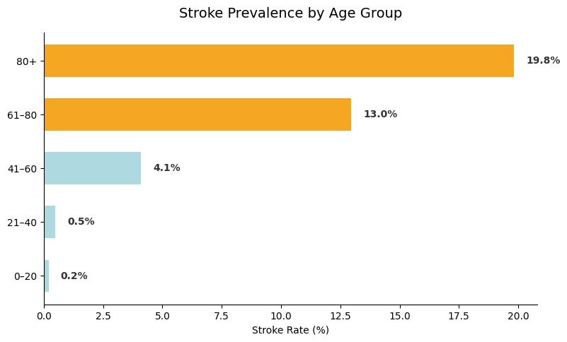
Figure 1. Stroke Rate by Age Group. Bars sorted ascending; orange = high risk (≥8%), blue = lower risk (<8%).

The high inflection point after the age of 60 indicates that the intensity of stroke prevention programs must be increased for those in their late 50s. For the group between the ages of 41 and 60, the inflection point indicates a moderate level of 4.1%.

3.2 Glucose Level vs. Age by Stroke Outcome
As can be seen from the scatter plot in Figure 2, there are two trends that can be identified. First, the cluster for the stroke patients is well above the threshold level for the diabetic patients, which is 126 mg/dL. Second, it is noticeable that the clusters for the two groups of patients exhibit a linear trend with respect to the ages of the patients and the corresponding glucose levels. Furthermore, the trend line for the stroke patients is not just steeper but also higher

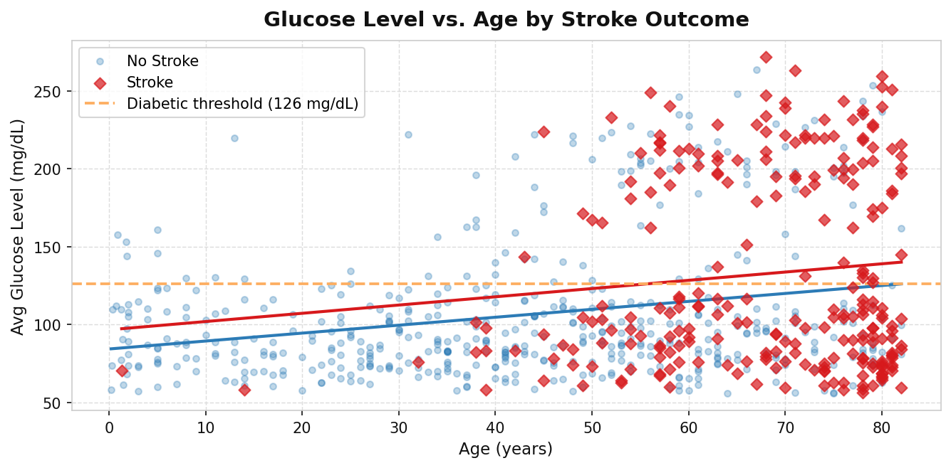
Figure 2. Glucose Level vs. Age by Stroke Outcome. Stroke patients (red diamonds) cluster above the diabetic threshold, especially at older ages. Linear trend lines are fitted for each group.

This chart confirms the hypothesis that metabolic conditions like uncontrolled blood sugar levels work synergistically to increase the likelihood of stroke. Patients who are above 60 years of age and have blood sugar levels above 126 mg/dl are at high risk.

3.3 Stroke Rate Heatmap: Age Group vs Risk Factor
Figure 3 represents the complete heatmap for the rates of strokes for all the combinations of the age group and the risk factors. It has to be noted that the darker red color represents the higher rates of strokes. It is very easy to identify the worst combinations from the heatmap provided above. It has to be noted that the values for the ranges 61-80 and 80+ are consistently warm-colored for the last rows of the heatmap provided above, which again emphasizes the importance of the factor 'age group.'
The highest single cell in the matrix is 80+, smokers at 27.3%, followed by 80+, heart disease at 25.9%, and 80+, high glucose at 23.7%. This heatmap strongly suggests that the importance of multi-factor risk assessment cannot be overstated since none of the factors by itself will give the complete picture.

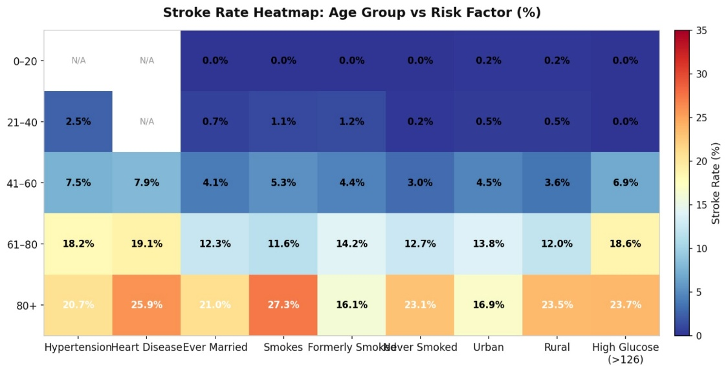
Figure 3. Stroke Rate Heatmap: Age Group vs Risk Factor. Cell values show stroke rate (%). Red = high risk, blue = low risk. N/A cells have fewer than 5 patients.

Conclusion
This data analysis of 5,109 healthcare records using three data visualizations reveals three main findings regarding stroke risk factors.

Firstly, it is obvious that age is a key risk factor for stroke. Although the risk of stroke among individuals below the age of 60 is relatively low, the risk increases dramatically after the age of 60, to a staggering 19.8% among individuals aged 80 and above. It is obvious, therefore, that the interventions should target individuals who are about to turn 60.

Secondly, it is obvious that cardiovascular risk factors are key contributors to the risk of stroke. It seems obvious, for instance, that heart disease and hypertension are two of the strongest risk factors for stroke, implying that the risk of stroke could be managed through the proper management of these two risk factors using drugs and lifestyle modifications.

Thirdly, it is obvious that the presence of combined risk factors creates extremely high-risk populations. It is obvious, for instance, from the heatmap visualization that individuals who are above the age of 80 and have other risk factors like smoking, heart disease, and high levels of glucose have a higher risk of suffering from stroke.

